Eligible Qualified Census Tracts (QCTs) in Covington, KY
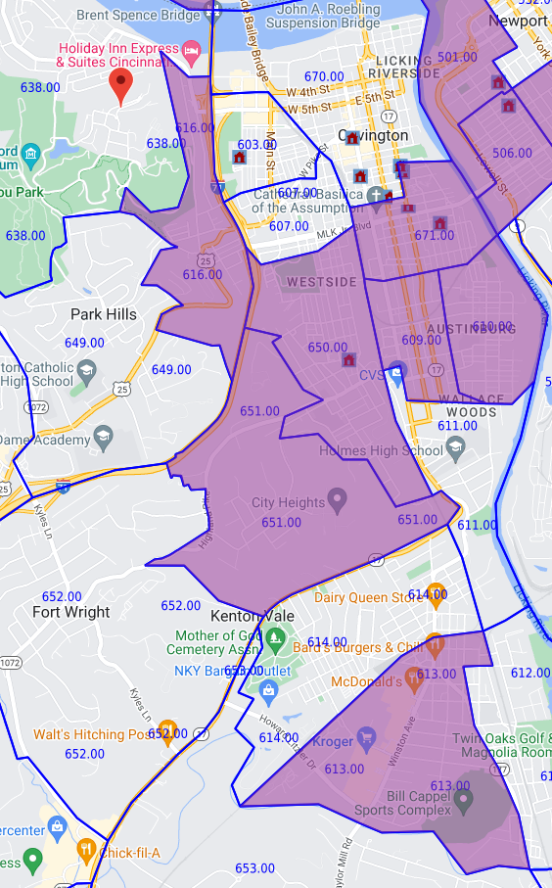
Note: QCTs 501.00 and 506.00 are in Newport, KY and are not part of the eligible area.

